

**Model Documentation of Interest Rate Risk Management System**

**PROFITstar® 2018 [Version #2018.768]**

**Treasury**

September 2021

|  |  |  |  |
| --- | --- | --- | --- |
| Version History | Date Changes Made | Author | Description of Changes |
| 1.0 | 9/21/2020 | Adrian Xin Long | Consolidated Draft version |
| 2.0 | 8/23/2021 | Adrian Xin Long | Update based on ERM findings and version upgrade |

|  |  |
| --- | --- |
| Model Information |  |
| Model Name | PROFITstar® |
| Model Owner | TRY |
| Model Status | Deployed |
| Model Developer(s) | Vendor |
| Model Implementer(s) | TRY; ADC |
| Model User(s) | TRY ; MRD; ERM |
| Contact Information | Adrian Xin Long/Harry Guo |

|  |  |  |  |
| --- | --- | --- | --- |
| **Approved by** |  | | |
| Charlie Peng  SVP & Head of Treasury  TRY |  |  |  |
| Signature |  | Date |

|  |  |  |  |
| --- | --- | --- | --- |
| **Reviewed by** |  | | |
| Harry Guo  SVP of Treasury  TRY |  |  |  |
| Signature |  | Date |

Table of Contents

1. Executive Summary 5

1.1. Model Tiering 5

2. Business Background 5

2.1. Business Profile and Model Use 5

3. Modeling Data 6

3.1. Model Input 6

3.2. Data Governance 7

4. Model Methodology and Development 8

4.1. Model Background 8

4.2. Limitation and Assumptions 11

5. Model Output Analysis 13

5.1. Non-parallel Scenarios 14

5.2. Other Ad-hoc scenarios 14

5.3. Sensitivity Test 14

5.4. Back Testing 14

6. Model Implementation 15

6.1. Implementation process 15

6.2. Implementation testing 15

7. Model Operational Control 16

7.1. Overall operation control 16

7.2. Version Control 16

7.3. Model User Manual 17

8. Model Governance and Monitoring 17

8.1. Model Governance 17

8.2. Ongoing Monitoring 20

9. Reference Information 20

9.1. External Regulations 20

9.2. Other related branch policies, procedures, and/or guidance- 20

9.3. Glossary 21

Appendix 23

A. PROFITstar® Download Setup Option 23

B. PROFITstar® Maturity Repricing Setting 30

C. Example on key NII and EVE calculation components 33

1. Executive Summary

Treasury Department (TRY) identifies, quantifies and monitors Interest Rate Risk on Banking Book (IRRBB). TRY Routinely uses vendor provided model PROFITstar® from Jack Henry & Associates, Inc., to estimate and report Net Interest Income (NII) and Economic Value of Equity (EVE) and along with their sensitivities to the Asset Liability Management Committee (ALCO) and Market and Liquidity Risk Committee (MLRC). TRY policy and procedure is designed to follow the guidance as prescribed by BOCNY Model Risk Management procedure (MRM) [6], OCC Bulleting 2011-12 Supervisory Guidance on Model Risk Management [1], and the OCC Interest Rate Risk Handbook [2].

This Document describes the key aspect of TRY’s Model Risk Management with respect to PROFITstar®. Conforming to the BOCNY Model Risk Management Procedure, this document is broken down into the following sections.

**Section 2:** Business Background describes the general business background and what the model intended to measure.

**Section 3:** Model Input describes the model’s data need.

**Section 4**: Model Methodology and Development provides information of model input, methodologies and output and its limitations.

**Section 5:** Model Output Analysis lists the different testing used to assess the accuracy of the model.

**Section 6:** Model implementation describes the implementation process.

**Section 7:** Model Operational Control outlines the version control and reference to the model user manual.

**Section 8:** Model Governance and Monitoring describes role and responsivities and the overall monitoring process.

**Section 9:** References

* 1. Model Tiering

PROFITstar® is an Asset & Liability Management model used by TRY to provide interest rate risk measurement on NII and EVE. Interest rate risk measures such as NII and EVE are obtained through projection of financial statements information using assumptions derived from expert judgement and/or historical analysis.

Risk measures are quantified as the ($ or %) change of an interest rate shock relative to the base scenario. Interest rate risk can be relatively complex, as modeling generally involve multiple assumptions and may have interaction with other risks, i.e: Credit risk. PROFITStar Model is rated as Tier 1 under the BOCNY model tiering guidelines.

1. Business Background
   1. Business Profile and Model Use

TRY identifies, quantifies and monitors Liquidity Risk and IRRBB. Specifically, the bank assigned TRY the responsibilities in routinely monitoring IRRBB activities in balance sheet and timely reporting Key Risk Indicators (KRI) information to Asset Liability Committee (ALCO).

The scope of the model covers the entire banking book. Since the model’s primary purpose is to assess interest rate risk, items that have interest rate risk component are projected[1]. Generally these items are on balance sheet interest bearing assets and liabilities such as loans and deposits, but Off balance sheet items relating to the banking book hedge such as SWAP[2] may also be included. Banking book hedge are general interest rate derivative with the intention to either protect the market value or the cash flow of the underlying. BOC uses swap to maintain the fair value of the asset, by converting a fixed rated loan into a variable rate loan.

Asset items include all loans, Due from bank, Security Investment, and any other banking book interest earning assets accounts (such as Reverse Repo). Liabilities items include all customer deposits, brokered deposits, due to bank, and any other banking book interest bearing liabilities accounts (such as Repo). ~~Unless stated otherwise~~Generally the categorization of product is based on the bank’s accounting definition and data are mapped using FMD’s TB line structure. ~~User should refer to the FMD’s TB line structure relate to how product and income category are defined.~~ (See the next section on Model Input General Data Categorization for more detail)

In addition, Earning at Risk measurement focuses on Net Interest Income measurement, therefore only interest income and interest expense related items are within the projection scope. Non- interest income such as commission and other fee income are not projected.

The main purpose of the PROFITstar model is to assess the interest rate risk through report of NII and EVE, where: NII assesses the short-term profitability while EVE examines solvency. Their sensitivities are constantly being measured and are monitored through KRI. A breach in threshold would trigger additional action to help control the risk. Report relating to these interest rate risk items are considered model outputs as assumption and account setting will affect the measurement of risk.

PROFITstar also produce ALCO reports that contain financial profile information. The information on these reports, unlike those of NII and EVE, are **not** considered model output as they can be created independently using a spreadsheet. In essence, these reports are only a simple transcription of the initial data input. Two main examples are Currency data[3] and Off-Balance Sheet items such as Loan Commitments.

1. Modeling Data
   1. Model Input

What Data are needed to run the Model

In term of Model Input, the download file setup defined the linkage between raw data file and PROFITstar®. There are three main types of data files needed to run the Asset and Liability Management (ALM) model: Databank file data, General Ledger file data, and Application file data.

1. Databank file data are information such as index rate that are used to help PROFITstar® with calculating certain important parameters. For example: the index rate is an important input used to determine offering rate based on deposit beta relationship.
2. General Ledger file data are Balance Sheet and Income Statement data, they are the data foundation used by the model as they reflect the institution’s Assets and Liabilities Profile.
3. Application file data provide detailed information relating to specific asset/liabilities accounts not captured by the General Ledger data., Generally these data represent instrumental details of the General Ledger data. PROFITstar®, for example, uses this information to help determine maturity/repricing schedule and other cash flow related calculations

|  |  |  |  |  |
| --- | --- | --- | --- | --- |
| Major Type | Type | Filename | PROFITstar® Module | Monthly Data |
| 1. Databank | a. Global | keyrates [MMDDYYYY] | History: Databank | External data obtain from PROFITstar® and Bloomberg relating to key rates |
|  | b. Organizational | Currently Data, such currency information, are entered manually. | History: Databank | Currency data obtained from CCY report |
| 2. General Ledger | a. Balance Sheet | FMD_GL ;  SATGL3 | History: Balance Sheet | Month End Balance; Average Balance |
|  | b.Income Statement | FMD_GL [4] | History: Income Statement | Income statement Balance |
| 3. Application | a. Loans | FMD_Loans.csv;  Opics_Loan Dep; | Maturity/Repricing | T24 loan detail data;  Opics loan detail data; |
|  | b. Investments | Opics_CD;  Opics_Bond | Maturity/Repricing | Opics investment data for CD and bonds; |
|  | c. Demand Deposits | FMD_DDA | Maturity/Repricing | T24 demand deposit data |
|  | d. Time Deposits | FMD_DEP | Maturity/Repricing | T24 time deposit data |

General Data categorization

Interest rate risk management or IRRBB in general involves the analysis of current and prospective risk associated with the movement in interest rate impacting the banking book position. By definition, Rate Sensitive Assets (RSA) and Rate Sensitive Liabilities (RSL) would be within the scope of projection, as the main goal is to determine interest rate risk. These assets and liabilities could be adversely affected by the change in interest rate. In the context of NII, interest rate may impact a product’s cash flow and affect the bank’s earning. For EVE, a change in interest rate could change the valuation of the product.

The general categorization of balance sheet and income statement data are defined using FMD’s T24 data structure and can be generalized as follows:

|  |  |  |  |
| --- | --- | --- | --- |
| **Category** | **Type** | **Descriptions** | **Rate Sensitive Asset/Liability** |
| Assets | Federal Reserve Balance | Reserve balances | X |
| Due From Bank | Demand and Time Deposits in Interbank, Affiliates and 3rd party FIs | X |
| Loans | Syndication Loans, Time Loans, Mortgages, and Trade Finance Loans | X |
| Repo Assets | Assets associated with Repo | X |
| Securities | Securities held in the banking book | X |
| Non RSA | Cash, Fixed Assets, Receivable, BOLI, Other Assets, other non interest bearing assets |  |
| Liabilities | Due to Banks | Demand and Call Loans from Interbank, Affiliates and 3rd party FIs | X |
| Customer Deposits | NMD such as Demand, Money Market, NOW, Savings, Time Deposits | X |
| Brokered Deposits | INDs and MMDA Brokered Deposits | X |
| Bond Issuance | CDARS and Bond Issuance | X |
| Repo Liabilities | Liabilities associated with Repo | X |
| Non RSL | Payable, Other Liabilities, other non interest bearing liabilities |  |
| Off B/S | SWAP Receivables | Receivable associated with SWAPS: IRSWAP and FV SWAP | X |
| SWAP Payables | Payable associated with SWAPS: IRSWAP and FV SWAP | X |
| Other Contingent Assets | i.e: Loan collateral |  |
| Other Contingent Liabilities | i.e: LC and Guarantee Issued |  |

How Data are transfer or input into the system

Every month data files are uploaded into the system using the Update Wizard[5], the main data transfer interface. There are four main modules in PROFITstar®: History, Maturity/Repricing, Projection, and Budget. The modules function from left to right. With the History Module as the data foundation of the model, the data upload process first imports balance sheet (General Ledger Data) and other important data such as key index rate (Databank Data) into system. Then, application level data are populated into the Maturity/Repricing Module. The more granular details from the application data help to calculate information such as the portfolio rate more accurately and further fine tune projections. Once these data are properly imported into the system, user can adjust assumptions in the Projection model and conduct analysis to determine the impact to NII and EVE.

In more technical terms, data files are first obtained from BOC’s core system and/or other sources including T24 and Opics. The PROFITstar® download setup setting identifies the location of the data file, and the data mapping transfer data into specific PROFITstar® account. It is through the uses of the key data field(s) such as TB lines that data are mapped into each PROFITstar® account.

*For detail relating to the setup and mapping of the data, please refer to PROFITstar® setup procedure: Download Setup in Appendix A.*

* 1. Data Governance

The data used for upload are obtained by ADC via email monthly. These data are reviewed, reconciled and archived into TRY shared folders.

Data Integrity

To ensure the accuracy of the data, the followings are executed:

* Ensure data file’s asset and liabilities balances
* Identify new accounts or product that might not have been setup into the system
* Review exception file reports
  + Balance/verify the History Module
  + Balance/Verify the Maturity/Repricing Module

1. Model Methodology and Development
   1. Model Background

Bank of China uses third-party IRR models from Jack Henry’s PROFITstar® to measure and manage interest rate risk. Data are imported into the system monthly to generate report on IRR risk, specifically relating to NII and EVE.

Mathematical and Technical Detail of the Model

To generate these IRR measurements, the bank runs the Interest Rate Sensitivity Analysis (IRSA) for NII and the Fair Value (FV) for EVE measurement. These two analyses are under PROFITstar®’s Projection Module. Using the bank’s current financial position data, which are stored in the History and Maturity/Repricing module of PROFITstar®, the Projection module allows user to create different scenarios using different assumptions that would alter the cash flow or characteristic of the balance sheet, a projected scenario with its own unique NII and EVE risk profile.

Because this is a 3rd party model, certain calculation process are proprietary and therefore the user might not able to fully replicate some of the calculations. As per OCC’s guidelines, it is not expected for the bank to duplicate the mechanics and mathematics of the third-party model. A general model certification that attests to the accuracy of the mathematics and logic of the model has been provided by PROFITstar®. The report was conducted by an independent third party, Angel Oak Consulting, date December 2017 [3]. To further enhance the understanding of the model, Bank of China has supplemented additional analysis and documentation relating to mathematical calculation of some of the more essential calculation in the model.

Model Input

To properly run IRSA and FV, the following inputs are generally needed for each of the interest bearing accounts.

1. **Key Rate Ties:** The key rate ties link the account to a suitable index and then define the beta between the offering rate and the index rate that allows the system to project future offering rate. Key Rate tie is important to both IRSA and FV.
2. **Prepayment:** the defined prepayment behavior of asset accounts that will affect the weighted average life as well as the amount of new volume projected. The prepayment is based on the historical Conditional Prepayment Rate (CPR). This parameter is important to both IRSA and FV.
3. **Decay:** the defined runoff behavior of Non-Maturity Deposit accounts that will impact the estimated value of those accounts. This parameter is important to FV.
4. **Fair Value Treatment:** selected treatment that will determine how value of the account would be determined -- whether it is through a quoted value, book value, or calculated value using discount method. This parameter is critical to the FV.
5. **Offering Rate Projection:** Projection assumption relating to offering rate obtained from FLUs.
6. **Interest Rate Projection:** Projection assumption relating to key interest rates obtained from SRD
7. **Balance Growth Projection:** Assumption correspond to the business plan relating to growth in balance sheet and changes in asset/liability mix structure.

Model Methodology

Methodology of IRR Measurement is quite straightforward for the IRSA and FV. Through the specification of the chart of accounts and income statement, and the incorporation of economic and behavior assumptions, it provides cash flow modeling capabilities necessary to generate estimates for NII and EVE.

* + - 1. Interest Rate Sensitivity Analysis (IRSA)

General methodology to calculate risk relating to NII, at the most basic level, involves the sum of multiplication of projected average rates by projected average balances within a time horizon such as 12 months. PROFITstar® using the IRSA would calculate NII in this fashion. The projected rate is determined mostly by the key rate tie relationship and the assumption about future interest rates. The projected average balance is derived from the bank’s current position, adjusted by the assumption relating to growth, and prepayment behavior that affect the new volume.

More specifically, in a static balance sheet, the month end balance is assumed to stay constant. So the month end balance of the subsequent month would equal to the month end balance of the prior month. Since the asset or liability would still amortize or run off, to maintain at a constant balance, the new volume would just be added in amount to replace the matured and prepaid amount. Interest income would then be separated into two components: Interest income/expense from current volume which generate income using existing portfolio rate, and those from the new volume which generate income using the projected offering rate. In a dynamic balance sheet, the composition of the balance sheet does not stay constant. So the month end balance will be based on projection of balance sheet growth. Therefore new volume may exceed or be less than the amount matured or prepaid. For a decreasing projection, the resulting projected month end balance would be constrained by the existing contractual maturity of account items if there is not sufficient amount of amortization, there would not be any new volume and the balance may not decrease sufficiently enough to reach the target balance. Generally new volume would make up the short fall between the target value and the resulting balance after maturity and prepayment. Interest income would then be calculated in the same way as the static based on current volume and new volume.

Interest rate shocks would impact offering rate through key rate tie relationship and new volume through the prepayment parameter.

* + - 1. Fair Value (FV)

General methodology for FV is to calculate the net present value of rate-sensitive assets, liabilities, and off-balance-sheet positions. If an observable market value is available, it would provide a more accurate picture of the fair value of the instrument. When that is not available, NPV can be used to estimate its value. Since NPV is especially sensitive to discount rate, NPV might not produce a value that reflect the fair value, but only the next best approximation. Specifically the value of those accounts are determined by calculating the NPV of all the projected cash flow using a discount rate. Since quoted and Book Value methodology are taken as is from data or user input, user would need to ensure treatment selected is appropriate and that the value derived is sound and supportable. User should be aware that for specific account type, certain treatment might be more appropriate than the discounted cash flow method (Discount). *For example: account that exhibit greater optionality might be better valued using quoted value from market or service providers if they are available.* When discount method is used, a spread between the account offering rate and index rate is applied to better capture the cost associate with the instrument. This spread, which is assumed constant through time and scenarios, is then added to the index rate for scenario analysis during discounting.

Interest rate shocks would impact offering rate and index rate which would affect discount rate. Also depending on the complexity of the product, shock could also alter the resulting FV through prepayment and decay speed.

Model Output

Standard Parallel Interest Rate Shock Scenarios

Using the above methodology, IRSA and FV would calculate each risk measures using the different interest rate scenarios. By default, the interest rate shock scenarios used are immediate parallel interest rate shock with 100 bps interval. For example: the current interest rate scenarios used are +/- 100bps; +/- 200bps, + 300bps, +400 bps, and the base scenario with no rate shock.

The NII at the base scenario and shocked scenarios are calculated separately. The difference of NII between the shocked scenarios and base scenarios is the NII sensitivity. The NII sensitivity at 200 bp parallel up scenarios divided by the NII of the base scenario is defined as BOCNY NII KRI, which has a limit of 20% and warning line of 15%.

Similarly, the EVE sensitivity at 200 bp parallel up scenario is defined as the KRI on EVE, which has a limit of $350 mil and warning line of $280 mil.[6]

Additional options and control are available to user, which allow further customization of interest rate scenarios. For example: Capability to conduct yield curve twist and non-parallel interest rate scenarios; sensitivity analysis through adjustment of change in decay and/or prepayment speed.

Result are produced in matrix form, showing the risk measure and its changes and sensitivity under the different interest rate scenarios. User may then compare the result and access the risk in relation to their risk limits.

A more quantitative description with examples on key calculation components on NII and EVE can be found in appendix C.

* 1. Limitation and Assumptions

Model Limitation

PROFITstar® has the following limitation based on the Model Certification report:

* All interest rates are statically generated and therefore would be limited on calculating dynamic option-adjusted cash flows or option-adjusted spreads (OAS). This has minimal impact to BOCNY as our products are mostly linear in nature.
* In addition, it does not have any credit adjusted cash flow capabilities.
* Interest-sensitive call options cannot be properly modeled without the use of Portfolio Manager. This has no impact to BOCNY since we don’t have these types of product

Although these limitation appeared in the report, the overall review did not reveal any material computational or logical errors.

General Limitation on NII and EVE

Earning-at-Risk and Equity-at-Risk are risk measure with different time horizons. User should understand their limitations.

NII result obtained from Interest Rate Sensitivity Analysis (IRSA) typically focuses on the risk with a time horizon of one to two years. Although user may run NII risk measure with longer time horizon, the result from longer horizon is generally less reliable. BOCNY uses 1 year horizon.

On the other hand, EVE result obtained from the Fair Value (FV) focuses on a long-term time horizon. It is more effective at capturing the effect of embedded options[7] and identifying risk relating to long-term repricing or maturity gaps on the current balance.

NII assumes the account reinvestment and repricing, and new business and volume growth. While EVE does not.

OCC Interest Rate Risk handbook’s Table 1: IRR Measurement Systems provides a simple overview of the limitations in capturing different type of interest rate risks.

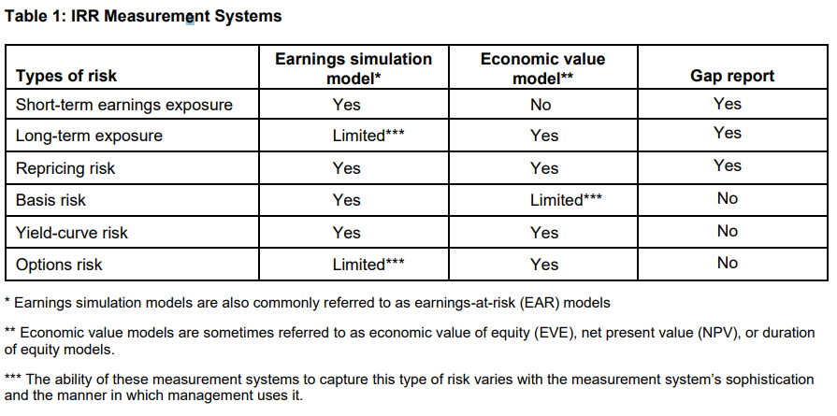

Assumptions

The 2010 Joint-Agency Advisory states that “financial institutions should perform historical and forward-looking analyses to develop supportable assumptions.” BOC conduct the historical analysis to determine assumptions for Decay, Prepayment and Beta. It also obtain information relating to projected offering rate from the FLUs, forecasted rate from the SRD, and Budget from HO. They are summarized as below and details can be found in the Appendix section.

**Prepayments**

**Update Frequency:** At least annually

**Source:** Empirical Historical Analysis

**Independent Reviewer:** ERM

**Setting Adjustment Field:** PROFITstar® Chart of Account >> Matr/Repr Tab

**Impacts:** NII, EVE

**Materiality level:** High

**Limitation:** Data might not have sufficient granularity;

past behavior might not continue in future

**Decay**

**Update Frequency:** At least annually

**Source:** Empirical Historical Analysis

**Independent Reviewer:** ERM

**Setting Adjustment Field:** PROFITstar® Chart of Account >> Matr/Repr Tab

**Impacts:** EVE

**Materiality level:** low, buthigh if NMD were not setup to decay immediately

**Limitation:** Data might not have sufficient granularity;

past behavior might not continue in future

**Beta Factor**

**Update Frequency:** At least annually

**Source:** Empirical Historical Analysis

**Independent Reviewer:** ERM

**Setting Adjustment Field:** PROFITstar® Chart of Account >> Key Rate Tie Tab

**Impacts:** NII, EVE

**Materiality level:** High

**Limitation**: Data might not have sufficient granularity;

past behavior might not continue in future

**Offering Rate**

**Update Frequency:** monthly

**Source:** Expert Judgement FLU input

**Setting Adjustment Field:** PROFITstar® Databank >> Rate

**Impacts:** NII, EVE

**Materiality level:** Medium

**Limitation:** Data might not capture credit risk

**Key Rate Forecast**

**Update Frequency:** at least quarterly or monthly when rate is volatile

**Source:** Expert JudgementSRD input

**Setting Adjustment Field:** PROFITstar® Projection

**Impacts:** NII, EVE under projection scenario only

**Materiality level:** Medium

**Limitation:** past behavior might not continue in future

**Balance Sheet Growth Forecast**

**Update Frequency:** At least annually

**Source:** HO and/or FLU input

**Independent Reviewer:** ERM

**Setting Adjustment Field:** PROFITstar® Projection

**Impacts:** NII

**Materiality level:** Medium

**Limitation:** Target might change due other factors i.e: economic environment or HO request

1. Model Output Analysis

Monthly, TRY uses PROFITstar® model to generate standard NII and EVE risk measures using the standard parallel interest rate shift scenarios. These results, after review by management and MRD, are included in the monthly ALCO package and presented to ALCO committee members. Results along with observation of trends and concerns are also presented to the MLRC committee, where risk are constantly monitored via risk limit, KRI, and committee members’ discussions.

Model validation is a key part of overall risk management framework. Since 2010, the regulatory expectation regarding model risk management has been heightened. In 2011, the Supervisory Guidance on Model Risk Management (the “Guidance”) was published by the Board of Governors of the Federal Reserve System and the Office of the Comptroller of the Currency (OCC)[8]. And in the most recent 2020 version of OCC published Interest Rate Risk Handbook[9], it expanded the discussion of model risk and model risk management, and indicated ongoing monitoring and outcome analysis are needed to evaluate the model’s performance, and to confirm that it has been appropriately implemented, and is being used and functioning as intended. Other regulatory agencies have adopted a similar stance with regards to the managing of model risk.

Output analysis therefore is a critical component to the proper establishment of model governance.

To assess the model’s performance, additional analyses are conducted periodically. Since PROFITstar® Model contains many parameters and assumptions, depending on the materiality of the input, a small change may have a significant impact to the overall result. These analyses when conducted correctly can provide additional insight by revealing errors and inaccuracies and help identify driving factors of the model.

The following analyses are conducted on a periodic basis:

* 1. Non-parallel Scenarios

TRY conducts periodic non-parallel interest rate shock scenarios to help identify yield curve risk. Since interest rate generally does not change in a parallel fashion, analysis that would alter the yield curve shape could provide a more realistic view of the bank’s risk exposure. That is because at different tenors of the curve changes in interest rate are not the same and different economic environment may yield different interest income and expense for the bank.

To conduct this type of test, TRY use the existing yield curve as the base, and then transform its shape by adjusting the slope of the yield curve to generate a steepening and a flattening rate scenario. This generally involve the following steps:

1. Set Base Curve by extracting the yield curve information from the current model
2. Identify the new shape of the yield curve by using a historical yield curve that exhibit the intended shape. Currently TRY uses the following historical curves:
   1. Steepening: 6/30/2004, when the US economic was in strong growth.
   2. Inverted: 3/5/2007, when the Subprime Crisis began to affect the US financial sector.
3. Shift the historical curve down to the base rate curve using a parallel shift adjustment equal to the difference between distant of the shortest tenor.
4. For NII: Add new Steepening and Inverted scenario by creating a rate projection for each rate scenarios under the setting IRSA >> ”Manage Scenario” >> “Add Custom”. Then Run IRSA and extract the result for the Steepening and Inverted scenario
5. For EVE: As EVE is calculated at t=0, “Add Custom” Rate Quick Projection setup used in NII would not impact the t=0 yield curve. In order to properly shift the yield curve used in the fair value calculation the following additional steps are needed
   1. Adjust all account with Matr/Repr >> Fair Value Options >> Spread Behavior >> Calculate to Static.
   2. Create a separate What if Scenario model for each non parallel scenarios and over write the existing yield curve data with the new curve data.
   3. Run FV and extract the Flat scenario EVE result for each What if Scenario.

The result of the analysis is shared with both ERM and MRD.

* 1. Other Ad-hoc scenarios

Periodically depending on the need of the organization, TRY would conduct additional scenario testing to help the bank identify impact to interest rate risk under unique circumstances. For example (Negative interest rate scenarios, and any other scenarios that is requested by upper management)

When conducting such test, TRY would identify the unique circumstance and condition of the ad-hoc request and select the appropriate setting to ensure model consistency. In the example of negative interest rate, TRY must first identify the appropriate setting in the model system such that the model calculation can account for the negative rates. Then NII and EVE risk measure are calculated and analyzed, with results shared with both ERM and MRD.

* 1. Sensitivity Test

At least annually, TRY would conduct sensitivity testing on key assumptions of the model. Assumptions such as Decay and Prepayments are tested using this analysis. Tests are conducted one assumption at a time. Results are generated using variation of the assumption parameter that is generally increase or decrease by a fix percentage relative to the base scenario’s value. With the isolation of key assumption, comparison of pre- and post- adjustment results would show impact from the isolated assumption which can be used to identify key drivers of risk and potential model error. NII and EVE risk measure are calculated and analyzed, with results shared with both ERM and MRD.

* 1. Back Testing

Back-testing is part of an on-going monitoring process. Typically the test involves the assessment of the accuracy of NII forecasts, within a pre-determined time frame, by comparing the actual NII against the projected one. Large differences that exceed the threshold limit set by the bank would trigger a need to take on additional actions. To more readily identify potential model errors, the analysis should consider unanticipated balance sheet changes driven by the material shift in economic and business environment, and control for factors that are extraordinary. This normalization process is needed such that the modeler would not make any over adjustment to the model parameter.

Time Frame

TRY conducts back-testing in a timeframe that is consistent with projection time frame. The projection is generated on annually basis for the calendar year. So an annual 12-month back-testing is conducted at the end of 4th Quarter of the following year. When performing the annual back-testing, TRY normally uses the 12-month projections generated at the end of prior year. For instance, 2017 annual back-testing shall utilize the Jan 2017 through Dec 2017 projections.

In addition to the annual back-testing, TRY performs quarterly monitoring of variance. The quarterly monitoring of variance is based on YTD total Interest Income and YTD average balance and is completed during the 1st, 2nd, and 3rd Quarter of the following year.

Analysis Methodology

The analysis assess model performance by comparing actual outcome with model forecasts.

NII variance($) is defined as the difference between Actual NII and Projected NII:

Average Balance Sheet and Month End Income Statement are used to perform the variance analysis in determining key factors contributing to the NII variance. Three major factors are rate variance contribution, volume variance contribution and mix variance contribution.

#### Rate Variance Contribution

The rate variance contribution measures how the difference between projected offering rates and actual offering rates affects NII. The annual rate is calculated as YTD NII divided by average monthly balance.

The following formula is applied to generate the rate impact on NII:

#### Volume Variance Contribution

The volume variance contribution measures how the difference between projected volume and actual volume affects NII. TRY compares the actual average balance against the forecasted average balance over the 12-month period.

The following formula is applied to generate the volume impact on NII:

#### Mix Variance

The mix variance measures difference between NII forecast and actual that are not explained by the rate and volume variance.

The following formula is applied to generate the mix impact on NII:

NII variance percentage is defined as NII variance divided by projected NII:

The positive sign of NII Variance suggests an under-projected NII, meaning that projected result is smaller than actual result; The negative sign of NII Variance suggests an over-projected NII, meaning that projected result is larger than actual result.

Any material change in long term strategy should be considered during the back testing. For example, extra ordinary economic events such as significant rate cut or rate hike that signal a new economic environment may cause initial projection to be no longer representative, therefore an updated projection more accurately reflecting the new reality may be used to replace the original projection.

### NII Variance Threshold

BOC-NY sets the threshold as 10% at aggregate level against NII Variance percentage for both annual back-testing and quarterly monitoring

### Back-testing Results Communication and Action Plan

TRY provides the annual back-testing results to ERM for review and MRD for information purpose only. TRY also shares, for information purpose, the quarterly monitoring result to MRD and ERM. TRY will further report the annual back-testing results to Markets and Liquidity Risk Committee (MLRC). TRY also reports critical issues to Assets and Liabilities Committee (ALCO).

If threshold is breached or certain business and economic environment situations arise, MLRC may suggest action or remediation plan to TRY after reviewing the results.

1. Model Implementation
   1. Implementation process

**Implementation Process**

System implementation for vendor related products generally involve the following steps

1. **Research/evaluation:** identify the right software, systems, and/or process solutions for managing IRRBB
2. **Installation**: install the software
3. **Moving data into system:** move relevant data into software
4. **Configure user and process**: customize system setting or setup system to reflect business and organization need and process
5. **Testing:** conduct test to determine accuracy of result
6. **Training:** train users provide them with sufficient working knowledge of the software require to conduct their work
7. **Deployment:** Roll out software for production for real business use

PROFITstar® is an ALM software BOCNY acquired in 1997. The system is already deployed and in production. This occurred before the MRM policy took into effect.

When there a major change to the system, such as a system upgrade or version update, TRY would work with ERM and conduct steps 2 to 7 as describe in the implementation steps above.

**System Components**

PROFITstar® contains 4 Modules: History, Maturity/Repricing, Projections, and Budget. Historical data relating to rates, balances and other financial data are stored in the History module. The Maturity/Repricing module contain information on maturity and repricing schedules. Using the information from the 1st two modules, the Projection module along with the inputted assumption would project the balance sheet for the institution, such that NII and EVE may be calculated. With the last optional Budget module, which contains the fiscal year budget plan and can be used to conduct comparison with actual result. The Budget module currently is not in use. These four modules are together in PROFITstar® and can’t be separately implemented.

* 1. Implementation testing

**Implementation Testing**

A new version of the software with significant change generally would require a version upgrade. A required testing is conducted to ensure that the change would provide accurate and reliable result. To determine accuracy and whether or not the change meets BOCNY application and requirement, TRY would conduct User Acceptance Testing (UAT) on a test version of the new application or version – installed by ADC. The UAT report, once completed, would be submitted to ADC and ORD. If there are aspect of the new application that does not meet the specification, TRY and ADC will work with vendor to determine a solution. Only when UAT is passed can the new version be deployed into production.

1. Model Operational Control
   1. Overall operation control

**Access Control**

To add user, TRY must complete the “Profitstar Request Form” and submit the request to ADC with approval from Department Head. Access level are different depending on the user need. For example: MRD access to PROFITstar® system would not have ability to “Move Month” or “Perform Consolidation”

**Model Recovery Plan**

Since PROFITstar® is a purchased software, BOCNY has obtained an escrow agreement in compliance to OCC Risk Management Guidance[10]. The escrow agreement would allow BOCNY to gain access to source code and program, so it can maintain usage of the model in the event if the vendor is no longer viable.

At least monthly model are backed up to the SQL server using the Update Wizard. In the event of a need for recovery, the Database can be restored following the “SQL Backup Restore” Instructions obtained from PROFITstar® [5].

* 1. Version Control

Version control is important in managing documents. As document may undergo many different changes, proper tracking, and labeling through versioning can help user to identify relevant documents for the specific purpose. For example: The version and date of the document provides clarity to users, allowing them to identify the policy applicable to a particular time.

**Version Information Page**

Documents that would need multiple revisions or is expected to be revised in the future should have version history information page at the beginning of each documents. At a minimum these documents should contain the following tables:

**Version History Table**

Running list of all the version of the document since from inception, describing the change, the person who made the change, the date of the change, and the Version number

**Document Information Table**

Meta data relating to the document that identify name of the document, owner location, contact person, effective date and other relevant fields

Other relevant fields are dependent on the nature and topic of the document. For example: for model validation, meta data should comply with BOC Model Risk Management Policy

**Approval and Review Table**

Table with information relating to the date and person conducting the review and approval.

**PROFITstar® Model Version**

PROFITstar® Version can be accessed through the system by navigating to the Help >> About PROFITstar® section. User may identify the most recent version available by navigating to the Help >> check For Updates.

**PROFITstar® Model Change/Update/Upgrade**

Depending on business need, PROFITstar® model may require update, upgrade or change. Upon identifying a need for an update to the model, TRY would request ADC to install the new version of the model onto a testing server. Once the new model is ready and is in a comparative state on the testing server, the user may then conduct UAT. The UAT would test to see if the new model have captured the required updates and still would accurately produce result. A testing report is generated for each upgrade and is submitted for review and approval to the department head. If approved, the new version would be implemented to production.

* 1. Model User Manual

Please see the following manuals and procedures:

* PROFITstar® Basic Training Guide [4].

1. Model Governance and Monitoring
   1. Model Governance

**Roles & Responsibilities**

**Treasury Department (TRY)**

TRY is the model owner of PROFITstar® and is ultimately accountable for model use and performance within the BOCNY MRM framework. It is responsible for

* Coordinating with all Model Risk Management (MRM) stakeholders and be responsible for the entire model life cycle
* Submitting the model submission package in line with the requirements defined by BOCNY MRM procedure
* Coordinating with different MRM roles to remediate internal (e.g. Model Validation and Internal Audit) and external (e.g. Regulators) findings
* Coordinating with Model User to monitor model performance and report issues to MRM

The TRY Department head delegate the responsibility of maintaining the model to the SVP and/or VP of the following subunits:

**Treasury Department - Business Management Team (TRY-BM)**

TRY-BM is responsible for Balance Sheet reporting and Data downloads, with responsibilities such as:

* Ensuring accuracy and integrity of balance sheet data
* Preparing and Uploading data into PROFITstar®
* Consolidating Balance Sheet on PROFITstar®
* Generating reports relating to Balance Sheet

**Treasury Department - Balance Sheet Management Team (TRY-BSM)**

TRY-BSM is responsible for overall function relating to risk measures, assumptions in model, and risk reporting, with responsibilities such as:

* Ensuring accuracy of risk result
* Calculating and updating assumptions
* Obtaining forecast from expert in bank as projection parameters( i.e key rate forecast from SRD)
* Obtaining/reviewing offering rate from each first line unit monthly
* Generating reports relating to Risk: NII, EVE, and gap reports etc.
* Conducting stress test, scenario analysis, and
* Performing NII model back testing

The model also requires additional inputs from the following units:

**First Line Units (FLUs)**

The FLUs, including Corporate Banking Department (CBD), Commodity Business Center (CBC), Financial Institution Dept (FID), Banking Department (BKD), Global Market Dept (MKD), Trade Service Dept (TSD), Queens Branch (QNB), are responsible for:

* Providing expert judgment and information on offering rate for bank products to TRY as model input

**Strategy and Research Department (SRD)**

SRD is responsible for:

* Providing expert judgement and industry consensus on economic environment and forecasting key interest rate to TRY as model input

And is supported by the following unit in term of system implementation and balance sheet chart of account setup in the system

**Financial Management Department (FMD)**

FMD is responsible for:

* Providing accounting policy and guidance.
* Updating and informing changes to Accounting Chart of Accounts that may impact model mapping
* Helping clarify accounting numbers with in financial statement

**America Data Center (ADC)**

ADC is responsible for PROFITstar® system implementation, PROFITstar® download file creations, and database and access control. This includes:

* Installing application system
* Adding/Deleting user
* Updating software
* Backing up recover data, and assisting TRY in retrieving necessary data for analysis
* Generating monthly PROFITstar® download files and email to TRY
* Communicating the ALCO report to ALCO members
* Reporting interest rate risk KRIs such as NII, EVE, and gap risk ratios to Monthly Market and Liquidity Risk Committee (MLRC)

The following units control the interest rate risk and provide independent review that challenge the existing model practice by conducting independent validation and review process:

**Market Risk Management Department (MRD)**

MRD, a model user and as the second line of defense in the area of market related risk, is responsible for:

* + Monitoring the results of Net Interest Income projection and non-parallel yield curve shift test;
  + Monitoring the monthly RAS KRI (NII/EVE) results;
  + Analyzing and challenging the above results if there are material changes.

**Enterprise Risk Management-ERM**

ERM, a model reviewer and as the second line of defense in the area of model related risk, is responsible for:

* Conducting PROFITstar model validation
* Collecting evidence of ongoing monitoring of the model
  + Identifying and recommending improvements to model

**Internal Audit (IAD)**

IAD, is the 3rd line of defense, it is responsible for:

* Verifying the consistency between MRM activities with MRM policy and regulatory requirements
* Verifying that MRM framework is well designed, effectively implemented and sustainably maintained

**Risk Management and Internal Control Committee (RMICC)**

The RMICC is a management-level committee of BOCNY, it is responsible for:

* Overseeing risk management practices of the Branch as final escalation point for model risk.
* Reviewing and approving the Branch’s major risk management and internal control policies and procedures.
  1. Ongoing Monitoring

As model characteristics and behaviors may evolve over time, to ensure the model still reflects the current reality that best estimate the risk, BOCNY conducts ongoing model monitoring periodically:

**NII back testing**

**Update Frequency:** annual full back testing and quarterly variance analysis

**Conducted by:** TRY

**Reviewed by:** ERM (annual only)

**Shared with:** ERM and MRD

**Threshold:** 10% variance

**Escalation/Reporting:** The annual back testing is reviewed by ERM and may be escalated to MLRC for wider discussion. TRY will identify the source of the variance and work with relevant FLUs to propose solution to resolve the difference. For example, by reviewing projection and ensure new projection is appropriate and reflect the new changes/economic environment.

**Update Assumptions**

**Update Frequency:** At least annually

**Conducted by:** TRY

**Reviewed by:** ERM

**Shared with:** ERM and MRD

**Threshold:** Not Applicable

**Non-parallel stress test, sensitivity test**

**Update Frequency:** At least annually

**Conducted by:** TRY

**Shared with:** ERM and MRD

**Threshold:** None

Additional Ad-hoc analysis are performed when needed.

* 1. Document Updates

This document will be updated at least every three (3) years and more frequently upon material changes to the model and/or the overall process.

1. Reference Information
   1. External Regulations

The following is a list (not exhaustive) of applicable regulations relating to Model risk management and interest rate risk:

1. OCC Bulletin 2011-12 / Federal Reserve Bulletin SR 11-7, “Supervisory Guidance on Model Risk Management,” April 4, 2011
2. OCC, “OCC comptroller’s Handbook: Interest Rate Risk“, Version 1.0, March 2020
   1. Other related branch policies, procedures, and/or guidance-

The following PROFITstar® documentation are related to this document”

1. Angel Oak Consulting, “Model Certification: PROFITstar® Classic”, December 2017
2. PROFITstar®, “Basic Training Guide”, 2018
3. PROFITstar®, “SQL Backup Restore”, 2018

The following procedures are related to this document

1. BOCNY ERM, “Bank of China New York Branch Model Risk Management Policy,” September 2019
2. BOCNY MRD, BOCNY Marker Risk Management Policy, June 2020
   1. Glossary

|  |  |
| --- | --- |
| **Abbreviation** | **Full Name** |
| ADC | America Data Center |
| ALCO | Asset Liability Management Committee |
| ALM | Asset Liability Management |
| BOCNY | BOC New York and satellite branches |
| CBC | Commodity Business Center |
| CBD | Corporate Banking Department |
| CHB | Chicago Branch |
| ERM | Enterprise Risk Management Department |
| EVE | Economic Value of Equity |
| FIs | Financial Institutions |
| FLUs | First Line Units |
| FMD | Financial Management Department |
| FV | PROFITstar® Fair Value |
| HO | Head Office |
| IAD | Internal Audit Department |
| IRR | Interest Rate Risk |
| IRRBB | Interest Rate Risk on Banking Book |
| IRSA | PROFITstar® Interest Rate Sensitivity Analysis |
| KRI | Key Risk Indicators |
| LAB | Los Angeles Branch |
| MLRC | Market and Liquidity Risk Committee |
| MRD | Market Risk Management Department |
| MRM | Model Risk Management |
| NII | Net Interest Income |
| NPV | Net Present Value |
| OCC | Office of the Comptroller of the Currency |
| ORD | Operational Risk Department |
| QNB | Queens Branch |
| RMICC | Risk Management and Internal Control Committee |
| RSA | Rate Sensitive Assets |
| RSL | Rate Sensitive Liabilities |
| SRD | Strategy and Research Department |
| TRY | Treasury Department |
| TRY-BM | Treasury Department - Business Management Team |
| TRY-BS | Treasury Department - Balance Sheet Management Team |
| UAT | User Acceptance Testing |

Appendix

1. PROFITstar® Download Setup Option

Download Setup Option can be accessed either directly from step 6 of the Update Wizard or via menu as shown in the screen below

Prior to the use of the setup, it is important to have the core data file and know the identifying key field(s) that will be used to map over data into PROFITstar®.

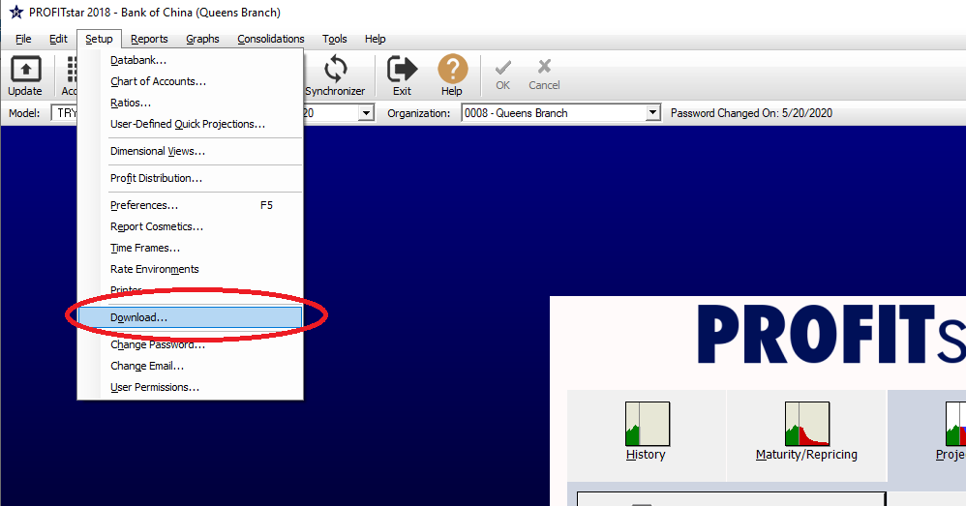

**Step by Step: Download Setup Option: Add New File**

|  |  |
| --- | --- |
| **1.**  Click the **Add** button to create a new file setup  . |  |
| **2.** Click the **Browse** button to locate the source data file you would like to import  • Use the file explorer window to locate and then Click the **Open** button |  |
| **3.** Select the **File Type** from the dropdown list  There are 9 File Type that fall under 3 major categories   1. Databank    1. Global Databank    2. Organizational Databank 2. General Ledger    1. Balance Sheet    2. Income Statement 3. Application Files    1. Loans    2. Investments    3. Demand Deposits    4. Time Deposits    5. Borrowings |  |
| 1. Click **New**. Under **File Layout**   • Enter a New name for the layout as Prompt by the message box |  |
| 1. The download setup will open a new window, File Layout Setup     This new window have 4 main section.   * 1. **Fields Section**: Identify the data fields that can be imorted into PROFITstar®. Required data field are mark with *   2. **Control Section**: provide the control needed to import the data   3. **Data Preview Section**: provide a preview of the raw data file   4. **Result Preview Section**: provide a preview of the resulting data file |  |
| |  | | --- | | 1. Identify the correct file format and adjust the format setting accordingly   **Note:** Once the format has been properly identified **,** the Raw Data Preview section will be shown in table format, with each column separate by the delimiter or other method such as fixed width | |  |
| 1. For each field, listed on the Field Section.   Identify and enter the corresponding **Column** from the raw data file that would contain the field information  If the Field is not used then adjust the **Field Source** to “Field not used”  Once all the field has been defined, Click on the **OK** Button |  |
| 1. Click **New**. Under **Account Links**   • Enter a New name for the layout as Prompt by the message box |  |
| 1. Click **Append**, to add new link to download setup   For each link, located the corresponding PROFITstar® account  And correctly select the type of link data and treatment  Once all the links have been defined, Click on the **OK** Button  **Note:** There could be a combination of Sort Field(s) that are used to map over to a specific account. |  |
| 1. Click **New**. Under **Organization Links**   **Note:** This does not apply to DataBank Files |  |
| 1. Click **Append**, to add new organization to download setup   For each link code, located the corresponding Organization that has been setup in PROFITstar®  And correctly select the type of link data and treatment  Once all the links have been defined, Click on the **OK** Button  **Note:** Code for organization is matched to “Branch or RC#” rather than Sort Field(s) |  |

**Download Setup Option: Edit Existing File**

To Edit an existing file setup, simply go into the specific section of the Download setup. Instead of Clicking the New Button, click on Edit and follow the steps from the previous section. Specifically

* For File Layout see steps 4, 5 and 6
* For Account Links see steps 7 and 8
* For Organization Links see steps 9 and 10

Generally we will edit an existing file or setup if

• New files is used and it contain new field or data structure that is different from previous structure, including but not limiting to new accounts added to General Ledger such as new product that would require new account setup in PROFITstar® and therefore New Link setup to import data properly

• If the location of the file has changed, user must use **Browse** button next to the **File Path** and edit the path and file name, so PROFITstar® can identify the file to be uploaded

1. PROFITstar® Maturity Repricing Setting

**PROFITstar®– Maturity Repricing Setting**

The Chart of Account setting’s Maturity Repricing Tab (Matr/Repr Tab) identifies the parameters the PROFITstar® model would use to create the Maturity and Repricing Schedule and how it would calculate fair value. Three important setting parameters are located on this tab

* **Prepayment**: behavior assumption parameter that defines how loan portfolio would prepay
* **Decay**: behavior assumption parameter that governs how NMD would run off
* **Fair Value Option**: treatment setting that define how PROFITstar® would calculate Fair Value

**1. Prepayment**

Prepayment is one of the key assumption in the PROFITstar® model. This assumption is used by the model to estimate the amount prepay for the loan portfolio. The user can access the setting parameter in the Matr/Repr Tab under the Chart of Accounts Setup.

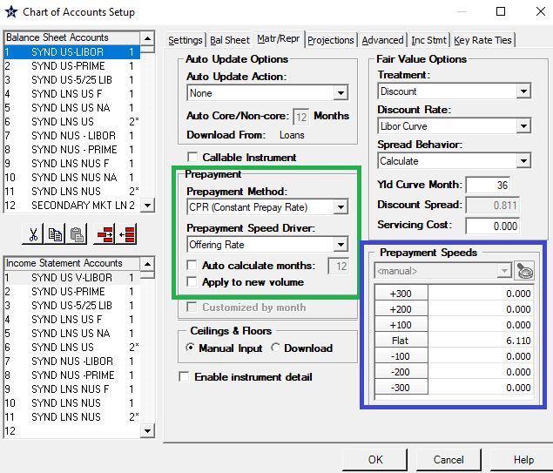

For each of the loan accounts, the user can

1. Select the payment method used (See location Green in pic)
2. Input the specific speed for each of the rate scenario. Flat scenario is the only required field. A 0 value in the other rate scenario means that the value would take on the flat scenario’s value (See location Purple in pic)

**Setting Details**

***Prepayment Methods/ (Decay Method)***

|  |  |
| --- | --- |
| Asset Side Methods | |
| None | No prepayment |
| SMM (Single Monthly Mortality) | Prepayment rate expressed as a monthly rate |
| CPR (Constant Prepayment Rate) | Assumes a constant proportion of loan will prepay each month |
| PSA (Public Securities Association) | Methodology where amount prepaid per month is dependent to the average age of the loan (or portfolio) |
| Percent of total balance | Uses the total maturity amount of the current month calculate prepayment amounts and assume to apply to all other time frames |
| User-Defined Table | User may create and define their own prepayment table to be used by PROFITstar® |
| Mortgage Prepay | User may use and store external mortgage prepay tables to be used by PROFITstar® |

|  |  |
| --- | --- |
| Liability Side Methods | |
| None | No prepayment |
| Monthly rate | Calculate like SMM method on asset side |
| Annual rate | Calculate like CPR method on asset side |
| Percent of total balance | Uses the total maturity amount of the current month calculate prepayment amounts and assume to apply to all other time frames |

If the Prepayment method is selected other than **None**, then the user can also enable the following settings

* ***Prepayment Speed Driver*** defines the rate that should be used to determine the prepayment or decay speed .
* ***Auto calculate months*** when enabled would allow the PROFITstar® to automatically calculate the estimated prepayment speed based upon the historical data stored in the system
* ***Apply to New Volume*** when enabled would also apply the prepayment to new volumes

**2. Decay**

Decay is another key assumption in the PROFITstar® model. This assumption help estimate the amount of run-off on Non-Maturity Deposit (NMD).

It only applies to accounts

* On the liability side of the balance sheet that subtotal into Total Deposits
* And has a Maturity Type of **N/A**

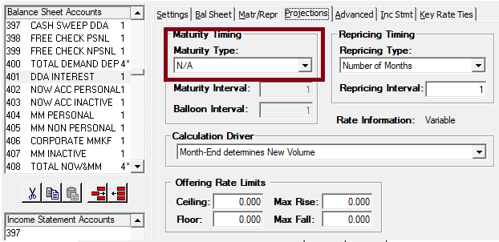

**Setting Up Decay**

In order to model decay, the user would need to have the following setting in the Chart of Accounts Setup > Matr/Repr Screen

1. **<**Auto Update Action**>** to “**Historical Balance in > Last**” (See location Green in pic)
2. **<**Decay Rate Method**>** to setting other than “None” (See location Blue in pic)
3. **<**Fair Value Options **>** Treatment**>** to “FAS107/Discount” (See location Purple in pic)
4. Select the desired discount rate, spread behavior and spread. (See location orange in pic)
5. Enter the decay rate in the prepayment speed matrix, this matrix is used to tell how the maturity schedule should react based on the changes to the projected offering rate. Although only the flat scenario is a required field, an account may experience different decay and therefore values for the other interest rate shock scenarios might be recommended. (see location red in pic)

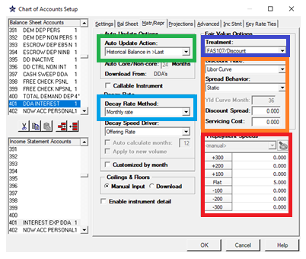

**3. Fair Value Options**

Fair Value Option is a critical parameter in the PROFITstar® model. To properly calculate the EVE each balance sheet account should have the best option selected appropriate to the attributes of that account.

|  |  |
| --- | --- |
| Fair Value Treatment options | |
| N/A | Not included in the Fair Value calculation or the Fair Value Report |
| Book | The Historical, Current, and Projected Fair Value of this account are equal to the balance of the account. |
| Quote | The Historical Fair Value of the account is manually input in the edit screens for the Historical Fair Value data item |
| Discount | The Current and Projected Fair Value of the account is calculated using discounting techniques (its Fair Value equals the sum of the discounted cash flows). This option is available only for rate-bearing Balance sheet accounts. |
| FAS107/Discount | This option can be used to calculate the book value of Demand Deposit Accounts for FAS107 purposes and for Economic Value calculations, the accounts can use decay rates or core/non-core to discount their value. |

The general recommendation for selecting the treatment are as follows:

• All non-rate bearing accounts except capital accounts are set to **Book**.

• All rate bearing accounts are set to **Discount**.

• Rate Bearing Securities, such as – Treasuries, Agencies, Municipals, CMOs, MBSs, Asset Backed Securities and other like accounts where a market value can be obtained are set to Quote[11] – If a market value cannot be obtained – use **Discount**

• Other accounts that add into Total Investments, such as – bank CDs, Mutual Funds, FHLB Stock, Federal Reserve Bank Stock, Corporate Bonds, Bankers Bank, Wescorp, BOLI, and other like accounts should use **Book** or **Discount** as appropriate.

• All capital accounts are set to **N/A** and are excluded from the calculation.

• Any Unrealized Gain/Loss Accounts on Investments are set to **N/A** and are excluded from the calculation.

• Any Valuation accounts such as premiums and discounts are set to **N/A** and are excluded from the calculation.

Actual setting would depend on the circumstances relating to the underlying product. For example:

1. In order for Non accrual loans to be considered as an earning asset, it must be categorized as a rate bearing account. The recommended setting above indicate all rate bearing accounts are set to Discount, but this might not be appropriate as the timing of the cash flow relating to non accrual loans are not certain. Although it is possible to create a synthetic book value by using **Zero Plus spread** setting with spread equal to 0 forcing each valuation to equal the original book value, such action might over-estimate the valuation if the book value have not properly accounted for the latest expected loan loss calculation. This illustrate that either **Discount**, **Book**, and/or **Quote** may be appropriate for this account.
2. Although the recommendation suggests a FV Treatment of **N/A** for valuation accounts such as premiums and discounts, this setting may produce an inaccurate valuation of the underlying account. A **N/A** setting would be appropriate if the underlying account such as investment is set to **Quote,** as a quoted market price would already incorporate the premium and/or discount. But when the underlying account is set to **Book**, having **N/A** would exclude the valuation of the premium and/or discount.

When either of the two Discount Cash flow (DCF) method is selected: **Discount** or **FAS107/Discount**, additional control fields such as discount rate, spread, and servicing cost would be available.

* Discount Rate defines the rate or rates that will be used to calculate the discount factor used to determine the present value of the account. This setting aim to capture the best opportunity cost to help provide a more accurate valuation.

The following type of rate options are available

* + **Offering Rate**: all cash flow will be discounted by the product’s current offering rate.

Note: Assuming the pricing is correct, the offering rate is one of the best representation of the opportunity cost but it does not reflect the term structure of interest rate.

* + A specific **Key Rate** in the Databank: all cash flow will be discounted by the key rate.

Note: Usually this is selected if there is an explicit relationship between the offering rate and the key rate.

* + A **yield curve** account: A yield curve can be constructed in the databank with tenor equal to each unique key rate. The discount rate at each time period for each cash flow would correspond to the tenor on the yield curve. This is the most accurate approach in calculating present value on PROFITstar as valuation would account for the time value of money.

Note: The most common yield curve is the Treasury yield curve, it represent the risk free investment opportunity or the opportunity cost of cash. To help capture the credit risk, a user may use the LIBOR swap curve as the referenced yield curve. The selection of the yield curve ideally should reflect the best estimate of the overall opportunity cost. For example:

1. the FHLB Yield Curve might not be appropriate as a discount curve for foreign banks. Although the curve might provide a general overall view of the funding cost for domestic banks, foreign banks are not eligible for membership and would have different funding source whose cost could be significantly underestimated especially during more stressful time.
2. Ideal method for securities is **Quote**, but in the event this is not available the **Discount** method using the Treasury Curve is the recommended setting from PROFITstar.
   * **Zero Plus spread:**  This option produces a constant rate defined by the Discount spread box. It will always assume the discount rate is zero under any rate shocks and therefore will establish a constant rate equal to the spread through any rate shocks.

Note: The user can force a synthetic book value by setting the spread to 0, or if it wishes to discount cash flow under any rate shock scenario using a constant rate defined by the spread.

* Spread is an important element as it tries to account for the risk element in pricing the product not captured by the benchmark discount rate or yield curve as defined earlier. The risk premium usually help represent the excess rate needed to compensate the investor. Generally assuming investment are risk free the opportunity cost of the cash flow would equal to the treasury curve, but to account for the additional risk element a risk spread can be added.
  + **Static** option enables manual entry of the discount spread. This option would be more precise but would require constant update on each account if the spread is not stable.
  + **Calculate** option is only available when the discount rate is a yield curve account. This option will enable the “Yld Curve Month” field, which is used to determine the tenor on the yield curve that the model will use to automatically calculate the spread over the existing offering rate. The general rule is to set the tenor equal to the average life of the product. The spread could be positive or negative and is used to recalibrate the discount rate. A positive spread would mean that the offering rate is higher than the benchmark curve rate, the positive difference would represent additional risk premium. While a negative spread would mean the product may possess additional benefit that may reduce the premium and provide a discount to the rate pricing, benefits are explicit or implicit added value such as help building existing client relationship, gain access to a desired collateral.etc
* User may further refine the calculation by adding a servicing cost (if available) representing the cost of account maintenance.

1. Key Assumptions.

Measuring and managing interest rate risk (IRR) are critical to minimize the impact of future interest rate volatility on earnings and net portfolio value. The Bank measures earning at risk with Interest Rate Sensitivity Analysis as the cumulative change in net interest income over the 12-month horizon divided by the annualized net interest income by given 100, 200, 300, 400, -100 and -200bp rate shocks. The Bank also measures Economic Value of Equity (EVE) sensitivity by given the same rate shocks as NII. To ensure the adequacy of the Bank’s interest rate risk measurement process, the appropriate assumptions are important for the analysis of IRR. The key assumptions encompass the key elements; Business volume projection, Interest rates projection, and Behavioral assumptions.

1. Balance Projection

The balance sheet profile of the bank generally does not stay constant. To obtain a risk measure that is more aligned with the bank’s expectation or balance target, a projection is added. Projection value are mainly derived annually from target derived from Head Office.

Head Office’s numbers generally provide the target value for the following broad categories of assets and liabilities. (see table below) Since these categories[12] may include multiple accounts, it would not be feasible to apply projection based on absolute change. Instead a relative change in term of a monthly growth rate is obtained relative to the previous year end balance. This growth rate is applied to each earning assets and interest yielding liabilities – non cash flow accounts such as discount and premium are excluded from these targets.

|  |  |  |  |  |  |  |
| --- | --- | --- | --- | --- | --- | --- |
|  |  | Change Amount | Dec 2020 ME BS | Increase (%) | Target | Monthly Growth Rate |
| Liabilities | Corporate Deposits | - | 10,691,142,549 | 0.00% | 10,691,142,549 | 0.00% |
| Personal Deposits | 1,000,000 | 312,513,756 | 0.32% | 313,513,756 | 0.03% |
| FI Deposits | (1,000,000,000) | 8,814,410,074 | -11.35% | 7,814,410,074 | -1.00% |
| Brokered Deposits | - | 11,989,862,444 | 0.00% | 11,989,862,444 | 0.00% |
| Assets | Corporate Loans | - | 15,801,226,326 | 0.00% | 15,801,226,326 | 0.00% |
| Trade Services | - | 3,031,296,200 | 0.00% | 3,031,296,200 | 0.00% |
| Residential Loans | (5,000,000) | 23,708,030 | -21.09% | 18,708,030 | -1.95% |
| Security Investment | 120,000,000 | 6,750,293,825 | 1.78% | 6,870,293,825 | 0.15% |

Not all accounts can be projected. Accounts such as balancing account does not have the ability for projection, rather they are automatically calculated by PROFITstar to ensure the balance sheet would balance after the projection. Currently the Fed Deposit is used as the designated asset balancing account, therefore its balance will fluctuate depending on the projection of the other accounts.

2. Offering Rate

An offering rate is the interest rate offered for new volume. In order to enhance the accuracy of the Bank’s interest margin projection, TRY calculates the weighted average portfolio rate and the weighted average rate on new volumes over products, and seeks the offering rate from business units on monthly basis. Business units can use the results as reference for the following month rate projection. Business Units also need to consider whether the new volume can represent or cover the products’ portfolio rate and all other non-rate factors (such as customer relationship ties, direct deposits, loan business relationship, branch convenience, etc.). Business units leverage all the factors and then provide the projection results and rational and support on the assumption to TRY. TRY reviews the information from business units and compare the offering rates from business against previous months, rate movement direction, and the benchmark range.

TRY also provide the business units with trend on key rates. Common industry rates like Prime, Treasuries, LIBORs, and Fed Funds are among the key rates covered. This trend is mainly derived from SRD. As on a quarterly and as needed basis, SRD would obtain the market consensus rate using vendors such as Blue Chip.

1. If there is no new volume in the prior 12-month, the most recent contract’s interest rate is considered, and applies the same for the following months.

2. Some offering rates are 0 because those accounts are idle accounts, such as Secondary MKT Loan, NAC MTG, etc.

3. The non-accrual loan accounts set up as rate bearing accounts in order to account for in earning asset and NIM calculations. Per Profitstar Model Validation finding, Non-accrual loan is set as interest rate tie to National Prime rate without spread.

3. Prepayment

**Data**

TRY have access only to the following data

* *OSD Payoff Report:*  Report from OSD that list all the loans paid off within a specified period
* *OSD Prepayment Report:* Report from OSD that list all the loans that are prepaid within a specified period
* *Data from LD and MG table on T24:* Obtain using SQL (see below)
* *FMD Month End Balance*

TRY obtains cash flow information relating to loans using the following SQL code.

|  |
| --- |
| SELECT *  FROM {}  WHERE ASOFDATE in ?  ORDER BY ASOFDATE |

This query is ran on both tables:

* {DATA_MART_US.dbo.MULTI_LD_BALANCE_HIST}
* {DATA_MART_US.dbo.MULTI_MG_FUTURE_BALANCE_HIST}

The 2 tables above provide information on current loans and their expected future cash flow. Prepayments are identified based on OSD reports with some adjustment on actual prepaid through reconciliation with the cash flow information.

**Calculating the Prepayment Parameter**

Currently prepayment speed in PROFITStar is calculated using the annualized[13] result of the 12 month’s single monthly mortality of loan products by TB lines using the following formula:

Equation P1:

More specifically using the monthly data, we construct the Single Monthly Mortality (SMM) for each loan.

The numerator of the equation represent the monthly-prepaid amount at time t. We use the OSD report to determine the prepaid amount.

The denominator represents the monthly-expected Loan remaining balance without prepayment. To obtain this value, we adjust the month end balance from the prior month with the expected principal payment of the current month. The FMD data file is used to obtain the prior month end balance as well as the contractual mature principal. While the partial contractual partial principal payment is obtained using the data from the LD and MG tables.

**Calculation**

Calculation of the prepayment parameters are conducted via spreadsheet. The spreadsheet consolidates the data and calculates the prepayment rate of each loan products based on their TB line using Equation P1:

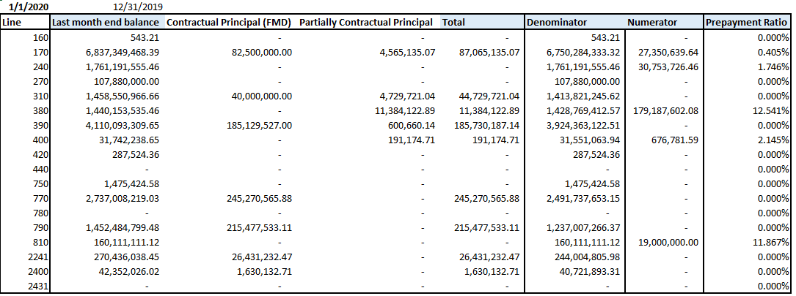

The resulting SMMs are annualized to obtain the average speed which will be used as the prepayment parameter for PROFITstar. The SMM used for the annualization should be more representative of the sample. Using an arithmetic average rather than a geometric average would be appropriate as the geometric average would better represent the median, whereas the arithmetic mean would more accurately represent the expected return.[14]



The resulting prepayment speed are compared to prior year’s result. TRY would looked for any significant changes or material difference and reach out to FLUs for more information. Adjustment are made to remove any extraordinary items and the final results are evaluated and reviewed by ERM.

4. Decay

Decay is the run off rate of non-maturity deposits (NMDs). It is a key behavior assumption to Interest Rate Risk (IRR) model. The assumption affect the determination of the average life of the bank’s deposits and generally would impact the EVE calculation.

Currently decay ratio in PROFITStar uses the calculated value derived from the 18 month’s historical account balance movement of each NMDs by applying the following formula:

Equation D1:

The above equation could result in value greater than 0, that is because in a month when withdrawal is less than the addition of new account balance the overall month end balance will be greater than the begging balance. A positive value does not equate to a withdrawal, therefore a maximum function is used to constraint the analysis only to the draw down behavior

**Data**

TRY have access only to the following data

* *Account Closing Balance:*  FMD month end balance
* *Account Opening Balance:* FMD month end balance, but using the prior month’s report
* *New Account Balance:* Obtain using SQL (see below)

TRY obtain new account balance information for each of the month of observation using the following SQL code.

|  |
| --- |
| SELECT  FMD.DESC1 TB,  AC.ID,  AC.CURRENCY,  AC.OPENING_DATE,  FMD.DEAL_LOCAL_BAL,  AC.ASOFDATE,  FMD.ASOFDATE  FROM  MULTI_ACCOUNT_HIST AC  LEFT JOIN  T_FMDDATA_hist FMD  ON  AC.ID = FMD.CONTACT_ID  WHERE FMD.ASOFDATE =?  ORDER BY TB |

Calculation of the Decay parameters are conducted via spreadsheet. The spreadsheet consolidates the data and calculates the Decay rate of each NMDs based on their TB line for each month using Equation D1:



Then the average of the past 18 months is used as the decay rate and presented into a table as show below



The calculation above is a simply descriptive analysis of past historical deposit trend. It is assumed that this historical trend is likely to continue into the future.

One of the main limitation of this assumption is that past behavior might not be able to be translated into the future. Depositor’s behavior are complex and can be difficult to estimate. The current data that is available to TRY would not allow the ability for more complex modeling to determine behavior.

To determine the stability of the results, TRY compares the current year’s result with the previous one. TRY identifies those with material deviance, contact the FLUs for more information regarding possible reason, and consult with second line (ERM) to determine if any proposed adjustment is appropriate and reasonable.

**Current Setting on Decay**

It should be noted that the current setting on Decay is conservative, as the model currently assumes most of the NMD accounts to decay immediately. This is characterized by the setting **<**Auto Update Action**>** to “**Historical Balance in First**”. When the historical balance is placed in first, PROFITStar assumes the account matures immediately, or there is immediate decay.

We can observe the difference in EVE risk measure in the 2 screenshot below. It can be shown that our current set is significantly more conservative as it has a lower NPV and higher sensitivity.

Current Setting: Result with Immediate Decay **<**Auto Update Action**>** to “**Historical Balance in First**”.

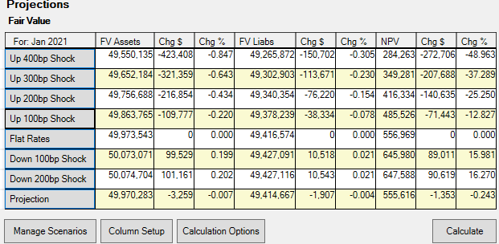

PROFITStar Proposed Decay Setting: Result with Decay **<**Auto Update Action**>** to “**Historical Balance < Last**”.

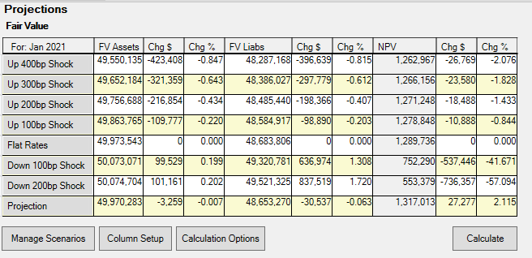

5. Beta

An important element in the PROFITstar model is the pricing of future new volume of NMDs. PROFITstar handle this by using Beta, which compares the magnitude of change in deposit rate relative to the key rate. This beta parameter provide a linear estimation of the offering rate. And it is a key behavior assumption to Interest Rate Risk (IRR) model. The assumption affect the determination of the future projected interest income and expenses.

In PROFITStar, Beta are generally setup as follows

**Setting Up Beta**

Beta assumptions only applies to accounts to Interest Bearing Accounts, or accounts that have Rate Information that are either Fix or Variable under the <Bal Sheet> Tab Section of the Chart of Account

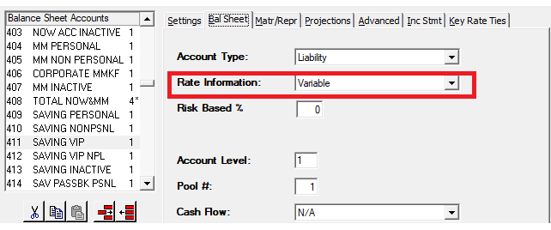

The linear relationship is inputted in the <Key Rate Tie> Tab Section of the Chart of Account. In the Key Rate Tie setting, the user may input the beta estimate in the <Multiply by> Field. PROFITstar also allows the ability to have different beta for different rate shock scenario and the implementation of a lag for each of the scenarios.

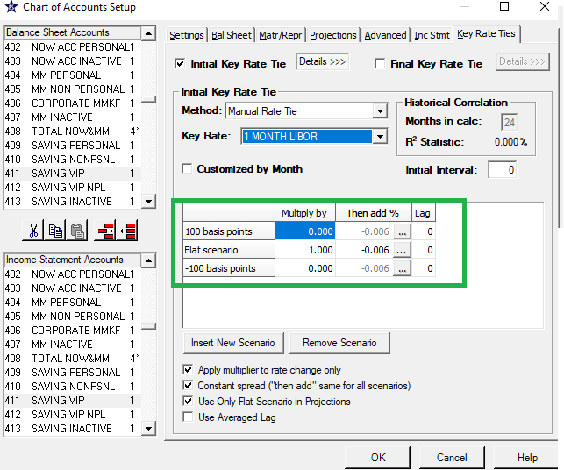

The default setting of the Key Rate Tie Method is “Manual Rate Tie”; this method allows the user to control all of the key rate setting. When user select the other methods, certain aspect of the calculation becomes automated. For example, a user may have PROFITstar automatically determine the beta relationship by selecting Auto Historical Calculation. The table below provide more detail regarding the difference between the methods.

|  |  |
| --- | --- |
| Method | Method Detail |
| Manual Rate Tie | Default setting which allows user control of all key rate tie setting. It is only this method that allows different beta for different rate scenarios |
| Auto Historical Calculation | Allows PROFITstar to determine the beta setting including the determination of which Key rate will be used as the referenced rate. User have only capability to adjust <Months in cal> and <Initial Interval> |
| Manual Historical Correlation | Similar to Auto Historical Calculation method but allow the user to select the specific key rate as the referenced rate |
| Calculated Spread | Similar to the default setting but auto calculate <Then add> parameter, or the spread difference between the offering rate and the key rate. |

In order to use a different beta for different rate scenario, the user must select Manual Rate Tie Method.

**Calculating the Beta Parameter**

Currently beta in PROFITStar are determined for each account of interest using a one variable ordinary least square regression (OLS). The regression uses the offering rate of the product as the dependent variable and the key market rate as the independent variable.

Equation B1:

This is the most simple way to analyze the relationship between offering rate and market rate. It is intuitive, as prices are generally set relative to a cost. The market rate represent a good cost variable since it influences the perception of opportunity cost. Even though the idea is simple, a historical analysis of this relationship would still provide insight relating to the sensitivity of each pricing to the change in market rate. Assuming this relationship is to remain constant, it can be carried over in the short run and allow PROFITstar to determine the offering rate on new volume. This sensitivity relationship can be as a slope called beta.

Although a regression can contain more than one variable or more than one beta. PROFITstar Key Rate tie setting is only able of capturing the one variable regression. The user can only select the market rate, in the <Key Rate> field, the beta into the <Multiply by> field, and the intercept to the <Then add>. There is no field that would allow another beta or independent variable.

**Determining the Key Rate**

One common way in selecting the Key rate is to select the market rate whose regression would result with the highest R-square. Generally, R-square represent the variability explained by the independent variable. A high R-square value could indicate a higher ability of the independent variable to predict changes in the dependent variable.

A high R-square result does not necessary mean that the independent variable would be the most appropriate Key rate. A statistical support for selecting the key rate is important but a qualitative factor that account for the real business process is more appropriate, as the relationship is more stable.

For example, if the bank’s rate decision specifically uses LIBOR rate to price its product, then even if there is another market rate that would produce a higher R-square, it might not be appropriate since it might not be able to predict future rate reliably. The observed correlation between the variables might be temporary high due to chance and not stable.

In PROFITstar, user may use “**Auto Historical Calculation”** method, such that it would allow the PROFITstar to automatically determine the beta as well as the key rate. PROFITstar would auto calculate and only allows the user to select the Months used to calculation the historical correlation

But if there is some sort of business process in pricing than it might be best to reflect and incorporate this relationship into the key rate tie specification.

**Dual Beta**

Generally beta parameter is dependent to the interest rate environment. For a liability, the bank might be less incline to increase their expense in a rising rate environment and more likely to reduce it in a decreasing rate environment. A unique beta for each type of rate environment could improve accuracy of interest rate risk measurement in PROFITstar.

In order to allow the ability to account for Dual Beta, the user must select “**Manual Rate Tie**” Method in the Key Rate Tie Setting. The user can *Insert New Scenario* and apply the unique Beta for each of the interest rate environment.

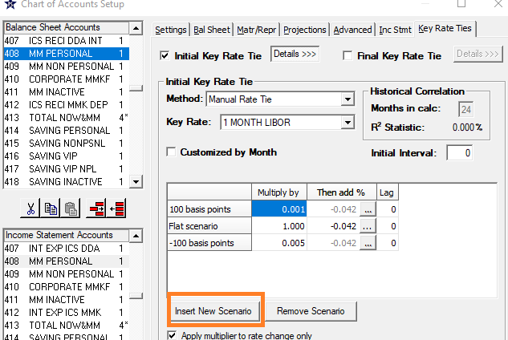

To capture the different beta, we can conditionally capture the different rate behavior by conditioning the analysis to period reflecting the up and down rate environment. To help determine whether a period is an up or down rate environment, TRY has selected the Fed Fund Rate as the reference rate.

Fed Fund rate is an important driving rate of the U.S economy. Some of the reason to use this rate are

1. Rate tend to be stable. Fundamentally, this is a rate that is determine by the FED with the long term strategic goal of the US economy in mind. Rate would not be fragmented or as volatile as other rate changes as this could provide bad signal to the market and affect market stability.
2. Rate change tend to cluster and bordered around a common economic regime.
   1. There is long period of consecutive increase or decrease
      1. *Rate decrease*: August 1 2019 to March 16 2020
      2. *Rate increase:* December 17 2015 to December 20 2018
   2. This type of clustering could mean there is a unique similarity between the time frame within the period. Generally identifying a unique economic regime.

*For example:* The period of Great Depression, Great Recession and Great Moderation are all unique period having their own unique economic structural changes policies and problems.

~~Generally TRY evaluates a 5 year time period for beta analysis, the period of analysis for 2020 coincidentally fall into the 2 segment period: 2015 -2018 and 2019 -2020. There could be incident where there could be more than 2 segment periods. The user should be in his/her best ability to control for any of the unique attribute associate with the period of evaluation.~~

~~For example, if the dual beta analysis was conducted for 2019, there would not be sufficient data point to analyze the down beta. The user might require to expand the time period such that it would include sufficient period of rate decrease to help obtain an estimate. Once the estimate is obtained, determine if it is possible to apply any qualitative adjustments, as the period might include behavior that is staled and no longer applicable to the future.~~

**Data**

TRY uses the data in PROFITstar to calculate the beta parameter.

* *Offering Rate:*  Monthly FLU’s rate survey manually enter into PROFITstar
* *Key Rate:* Monthly market rate imported into PROFITstar from external sources such as but limiting to PROFITstar, Bloomberg. Etc

**Selecting Historical Time Period**

There is a trade off between using a longer range of time periods to a shorter one. Longer range could contain period that exhibit different regime, which has uniquely different economic dynamics or rate setting behavior. As time period is extended it could introduce new factors that inherently change the dynamic of the process we are trying to evaluate. Although a shorter period would best reflect the recent business behavior, a shorter period might not have sufficient data point to help derive a reliable estimate.

User should select time period that sufficiently captures the behavior of interest and still be able to generate an estimate for beta. (See example in Dual Beta.)

**R-square**

As described in the selecting key rate section, a high R-square does not necessarily mean the specified relationship is the best and most appropriate one. R-square can be low due to lack of sensitivity that is either related to the time period of evaluation or due to the very nature of the account

* Low sensitivity could be a simple by product of a low or flat interest rate environment
* Low sensitivity could also be due to the nature of the product.

1. Example on key NII and EVE calculation components

General PROFITstar® Process

**Example:**

We use a simple example of CD to illustrate the key NII and EVE calculation components. The illustration also provide a rough understanding of the general NII and EVE calculation framework. Please note PROFITstar® is a vendor model, the calculation does not exactly reflect the actual calculation behind this black box model, but help approximate and provide user a rough understanding of the calculation process.

From Raw data into PROFITstar®

|  |  |  |  |  |  |
| --- | --- | --- | --- | --- | --- |
| **TB Line** | **4390** |  |  | **Product Type** | **CD issuance** |

|  |  |  |  |  |  |  |  |  |  |
| --- | --- | --- | --- | --- | --- | --- | --- | --- | --- |
| **Data Source** | |  | |  | | |  |  | |
|  | |  | |  | | |  |  | |
| **Data type** | **file name** | | **Data as of** | | **Total Amount from Data** | **Amt Type** | | |
| General Ledger File: | FMD_GL.csv | | 5/31/2020 | | $4,773,965,000.00 | Month End Balance | | |
| General Ledger File: | satgl3.csv | | 5/31/2020 | | $4,863,806,677.42 | Average Balance | | |
| Application File: | Opics_CD.csv | | 5/31/2020 | | $4,773,965,000.00 | Month End Balance | | |

The general ledger file provide month end and average balance at the broad chart account level. For this example, CD Issuance accounts are identified by data with TB line equal to 4390. PROFITstar® will aggregate all data with the key, TB = 4390, and store it into PROFITstar® CD Issuance Account.

The Opics_CD.csv file provide more detail level of the CD Issuance Account. Information at an application level provide the maturity of each individual contract and their balance. This information form the contractual cashflow of the product and is stored in the PROFITstar® Maturity/Repricing module for the CD Issuance account. In addition, for account that have data at an application level, the portfolio rate is calculated using the application level data.

Projections are generated by altering the following setting on PROFITstar®.

**Key Rate Projection:** Fed Fund is projected to increase from Current rate August 2020 0.090% to 0.100% in September 2020. Key rate projection are only applied to the Projection scenario, so it does not impact the Flat rate scenario which assumes rates remain constant. In addition, shock scenarios are parallel interest rate shift relative to the Flat rate scenario, therefore the shock scenarios also would not be affected by key rate projections.

**Figure 1:** **Key rate Projection**

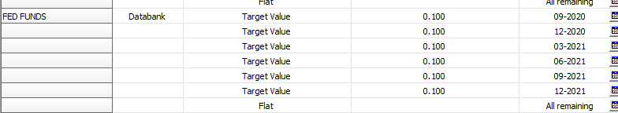

1. **Prepayment/Decay Assumption:** No assumption for CD Issuance

**Figure 2: Prepayment/Decay setup**

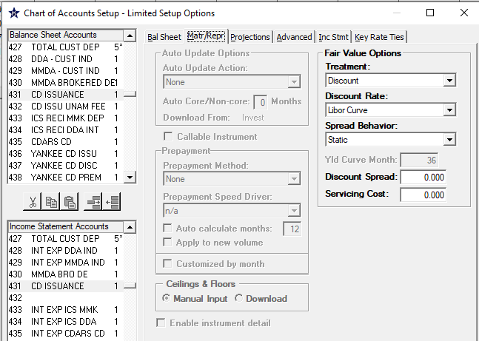

1. **Beta Assumption:** Generally the offering rate is projected based on the key rate tie relationship. The projected offering rate is used to determine new volume rate. As new volume would be part of the total portfolio, projected portfolio rate is impacted by key rate tie.

**i**.e: CD Issuance Offering rate is tied to FED FUNDS rate and is equal to Fed Fund rate + 0.060%.

The CD Issuance account has the key rate tie method set to “Manual Rate Tie”. This setting means that the spread must be manually entered by the user to define the beta relationship. This value would need to be recalibrated periodically if the offering rate and the projected rate is remain consistent as the value is not automatically calculated by the system.

If an account does not have any key rate ties relationship established and it is also a rate bearing account, then the projected offering rate is determined by manually creating the offering rate target rate in projection or it will assume to stay flat by default.

**Figure 3:** **Beta Setup**

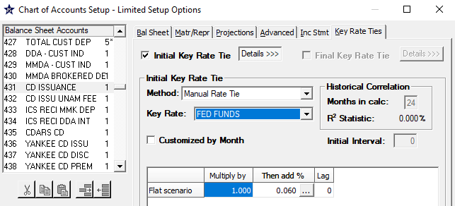

1. **Balance Sheet Projection**: Assume to grow at -0.570% until December 2020

**Figure 4**: **Balance Sheet Projection**

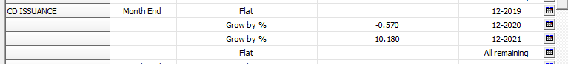

**Calculating EVE**

EVE is calculated using NPV, if the method selected under Fair Value option is “Discount” or “FASB 107/ Discount”. The weighted average life of the asset/liability is affected by the decay or prepayment assumption of the account. The adjusted cash flow schedule is used and discounted to the present to obtain the fair value of the account.

For each account, the NPV is equal to

**Formula 1**

Where i is the ith instrument in the portfolio, m is the maturity of the instrument, P is the principal, CF is the cash flow at time t, r the index rate at time t, and s the spread add-on rate.

Generally speaking, if the rate is fixed the contractual cash flow would be fixed; if the rate is variable, the cash flow would be repriced according to the repricing schedule at the new offering rate corresponding to the timing of the cash flow.

Discount rate is defined under Fair Value option. Figure 2 shows the discount rate setup. Specifically the setting for CD Issuance indicates that the Cash flow will be discounted using the LIBOR curve and there would be no discount spread. In addition, this discount spread relationship will remain static via time. Generally an account may have a spread to help capture the cost of credit risk, liquidity or other cost. The spread can be determined by the difference between the offering rate and the tenor rate identified under “Yld Curve month” field. This spread will then be applied to the entire LIBOR curve to obtain the set of discount rates used for the NPV calculation

In the CD issuance example, the 36 month tenors on the LIBOR curve is used to calculate the spread. Since the method used is “Calculated”, PROFITstar**®** would calculate the spread between the current month’s offering rate and the tenor rate on the LIBOR curve. This spread is then applied to obtain the different discount rate for the different time period. Generally speaking the tenor selected to calculate the spread should reflect as closely as possible to the characteristic of the product. Common practice include using a 36 month tenor for product that have a WAL around 36 month.

Pricing and opportunity cost, of course, can be based on other factors. As a bank may have unique competitive advantage that might justify its spread.

PROFITstar**®** separate the calculation in Formula 1 into 2 parts, the maturity principal portion and the interest/expense cash flow portion. Formula 2 below shows the break down. In this formula, d is the discount rate which is the rate that already accounted for the spread. The subscript i represent each product, t is the timing of the cashflow, m the time of maturity, P the principal.

**Formula 2**

+

**Obtaining the discount rate**

The data relation to maturity principal portion are obtained from maturity/repricing module. The index or the discount rate is based on the LIBOR Curve (or Government curve if government curve is used for some accounts) and is linearly interpolated between two available tenor points. Specifically

**Formula 3**

Here ri is the ith discount rate; t is the set of tenor points on the LIBOR Curve in months; j is the last tenor element that have a direct discount rate before time i.

For example: LIBOR has tenor set of {1,3,6,9,12….}

R(1) = LIBOR curve [tenor =1 ] or the 1 month LIBOR rate = 0.16

R(2) = LIBOR curve [tenor =1 ] + (LIBOR curve [tenor =3] – LIBOR curve[tenor =1 ]( (2-1)/(3-1) = 0.16 + (0.25 -0.16)(2-1)/(3-1)=0.205

Basically if there is not a direct discount rate in the LIBOR curve, then linear interpolation is done from the most proximate tenors to extract a discount rate

**Obtaining the FV Factor[15]**

Once the discount rate has been identified a Fair Value factor can be obtained. PROFITstar® usually treat payments as occurring in the middle of the month. So the discount factor must be adjusted to account for this timing. Since time period are calculated in the dimension of months, a middle of the month adjustment would equate 0.5 adjustment.

**Obtaining the Principal or maturity amount**

The Table 1 below shows the present value of the principal portion for CD issuance. Specifically the Maturity amount correspond to the contractual maturity cash flow which can be obtained from the maturity/repricing module.



**Table 1: Present Value calculation for Principal/Maturity for CD Issuance**

|  |  |  |  |  |
| --- | --- | --- | --- | --- |
| **Index** | **Time** | **FV Factor** | **Maturity Amount** | **PV of Maturity Amt** |
| 0.16 | Sep-20 | 0.999933 | 709,247,000.00 | 709,199,720.02 |
| 0.205 | Oct-20 | 0.999741 | 1,366,203,000.00 | 1,365,849,091.70 |
| 0.25 | Nov-20 | 0.999472 | 269,488,000.00 | 269,345,821.29 |
| 0.27 | Dec-20 | 0.999202 | 1,199,652,000.00 | 1,198,694,261.72 |
| 0.29 | Jan-21 | 0.998893 | 342,201,000.00 | 341,822,218.64 |
| 0.31 | Feb-21 | 0.998563 | 0 | 0 |
| 0.3333 | Mar-21 | 0.998182 | 9,646,000.00 | 9,628,467.95 |
| 0.3567 | Apr-21 | 0.997754 | 359,278,000.00 | 358,471,015.37 |
| 0.38 | May-21 | 0.997286 | 139,710,000.00 | 139,330,834.80 |
| 0.4033 | Jun-21 | 0.996779 | 124,529,000.00 | 124,127,900.30 |
| 0.4267 | Jul-21 | 0.996233 | 95,991,000.00 | 95,629,398.11 |
| **Totals** |  |  | 4,615,945,000.00 | 4,612,098,729.91 |

**Obtaining the income/expense cash flow**

The table below shows the present value of the income/expense cash flow for the Current Volume. The cash flow are accrued interest/Expense for the respective period. PROFITstar does not explicitly indicate the formula or how the cash flow is calculated, but generally speaking, accrued interest/expense expect to follow conventional calculation. That is if the rate is fixed the contractual cash flow would be fixed; if the rate is variable, the cash flow would be repriced according to the repricing schedule at the new offering rate corresponding to the timing of the cash flow. The Fair Value Factor would need to account for two parts. The Maturity discount factor (which contain the 0.5 adjustment) for the income/expense on the maturing balance and the full discount factor for the income

**Table 2: Present Value calculation for Cash flow**

|  |  |  |  |  |
| --- | --- | --- | --- | --- |
| **Index** | **Time** | **FV Factor** | **CF Amount** | **PV of CF Amt** |
| 0.16 | Sep-20 | 0.999872231 | 2,379,688.33 | 2,379,384.28 |
| 0.205 | Oct-20 | 0.999671424 | 2,033,966.82 | 2,033,298.51 |
| 0.25 | Nov-20 | 0.999374151 | 1,653,426.55 | 1,652,391.75 |
| 0.27 | Dec-20 | 0.999127202 | 1,075,120.38 | 1,074,182.02 |
| 0.29 | Jan-21 | 0.998792107 | 448,506.93 | 447,965.18 |
| 0.31 | Feb-21 | 0.998442805 | 385,141.31 | 384,541.57 |
| 0.3333 | Mar-21 | 0.998040191 | 422,040.90 | 421,213.78 |
| 0.3567 | Apr-21 | 0.997654957 | 235,571.99 | 235,019.56 |
| 0.38 | May-21 | 0.997162177 | 51,169.80 | 51,024.59 |
| 0.4033 | Jun-21 | 0.996677486 | 22,047.58 | 21,974.33 |
| 0.4267 | Jul-21 | 0.99623296 | 6,199.41 | 6,176.06 |
| **Totals** |  |  | 8,712,880.00 | 8,707,171.63 |

The sum of PV of Maturity Amount and PV of Cash flow Amount is the NPV for the CD Issuance

NPV CD issuance = $4,620,805,901.53 = $4,612,098,729.91 + $8,707,171.63

The same method is completed on all asset and liabilities with Discount[16] method, and combined with those asset and liabilities with “Book” and “Quoted” treatment, respective those accounts that are valued at book value and those that are priced from external market quote. The sum of all asset value minus the sum of all liabilities would provide the base EVE.

**Rate Shock**

In the event of a rate shock, the index rate would shift by the amount of the shock. Table 3 shows the impact to NPV. The shocked EVE is obtained the same way as described above for the base, with the difference in rate, which may also affect decay and prepayment. The expectation is, if there is a rate shock, the shock would impact the cash flow of variable rate product. Due to limitation on documentation, we are currently unable to fully back calculate the value. We were able to observe that impact to rate shock does affect the value of the CF amount as expected. Due to the materiality of this calculation, currently we rely on the model validation as a check for the accuracy of the calculation.

**Table 3” NPV calculation of +200bps shock on CD Issuance**

|  |  |  |  |  |  |  |  |
| --- | --- | --- | --- | --- | --- | --- | --- |
| **Index** | **Time** | **FV Factor** | **Maturity Amount** | **PV of Maturity Amt** | **FV Factor** | **CF Amount** | **PV of CF Amt** |
| 2.16 | Sep-20 | 0.999101 | 709,247,000.00 | 708,609,251.70 | 0.99827787 | 2,379,688.33 | 2,375,590.19 |
| 2.205 | Oct-20 | 0.997219 | 1,366,203,000.00 | 1,362,403,774.47 | 0.99647428 | 2,033,966.82 | 2,026,795.63 |
| 2.25 | Nov-20 | 0.995265 | 269,488,000.00 | 268,212,058.85 | 0.99438611 | 1,653,426.55 | 1,644,144.40 |
| 2.27 | Dec-20 | 0.993313 | 1,199,652,000.00 | 1,191,629,928.24 | 0.99269162 | 1,075,120.38 | 1,067,263.00 |
| 2.29 | Jan-21 | 0.9913 | 342,201,000.00 | 339,223,696.91 | 0.99050933 | 448,506.93 | 444,250.30 |
| 2.31 | Feb-21 | 0.989351 | 0 | 0 | 0.98846413 | 385,141.31 | 380,698.37 |
| 2.3333 | Mar-21 | 0.987356 | 9,646,000.00 | 9,524,040.53 | 0.98637312 | 422,040.90 | 416,289.80 |
| 2.3567 | Apr-21 | 0.985264 | 359,278,000.00 | 353,983,607.99 | 0.9846193 | 235,571.99 | 231,948.73 |
| 2.38 | May-21 | 0.983137 | 139,710,000.00 | 137,354,029.94 | 0.982373 | 51,169.80 | 50,267.83 |
| 2.4033 | Jun-21 | 0.980976 | 124,529,000.00 | 122,159,907.29 | 0.98038069 | 22,047.58 | 21,615.02 |
| 2.4267 | Jul-21 | 0.978781 | 95,991,000.00 | 93,954,119.44 | 0.9787805 | 6,199.41 | 6,067.86 |
| **Totals** |  | Totals | 4,615,945,000.00 | 4,587,054,415.35 |  | 8,712,880.00 | 8,707,171.63 |

**Sensitivity**

EVE sensitivity is determined by the difference between the shocked EVE to the base. The current KRI, involve using the difference between +200bps scenario and base scenario.

**Calculating NII**

NII is calculated based on the interest/expense from the current volume as well as the new volume. Interest income/ expense is a function of the balance and the rate on the yield earning asset or liability. Balance on each account is first adjusted to meet the projection target, assuming it is feasible and internally consistent[17].

Prepayment assumption are then applied to determine new volume, as it impacts the amount that would be matured each month, and therefore the amount of new volume that would be required to replenish the balance to the target value that was projected (or in static scenario, the month end balance of the last month).

For the new volume, offering rate projections are determined based on the relationship defined by the beta and the index rate. The projected offering rate along with the new volume is used to help determine the interest income/expense.

The current volume are derived from existing maturity repricing schedule, or the contractual cash flow if there is no prepayment. If prepayment exist then the cash flow will be adjusted accordingly. Therefore the income or expense are the contractual portfolio income or expense adjusted by prepayment. The initial pool of contractual obligation or instrument form the contractual portfolio, as it amortized, the weighted portfolio rate will adjust.

The combined income and expense for current and new volume of all NII related accounts are aggregated through the time horizon of 1 year to obtain the 1 year NII.

**Formula 4**

**Figure 5: Projected Values for CD Issuance**

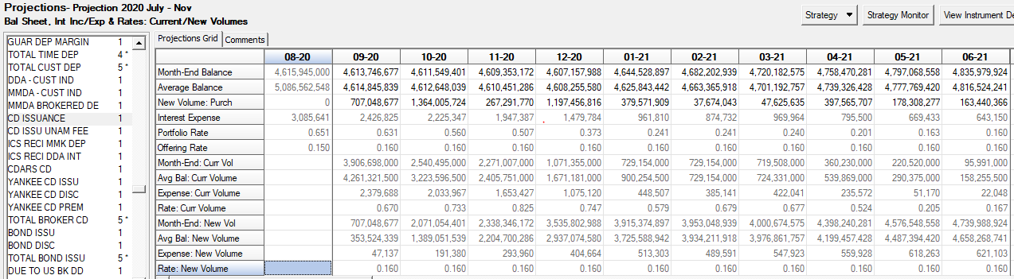

Using the data from Figure 5, we can see that the balance change reflect the balance sheet projection (Figure 4). Specifically the growth from 8/1/2020 to 12/1/2020 follows the annualized change of -0.57%

**Figure 6**



We can also see that the offering rate follow projections setup as well.

The Fed fund rate for August is 0.090% and it increased to 0.100% as defined under the key rate projection (Figure 1)

The beta relationship define projected offering rate to be a one to one relationship in term of change of the index rate with an add on of 0.060%. (Figure 3) Since the index rate for CD issuance is the Fed Fund rate, its offering rate would equal to 0.150% = 0.090% x 1 + 0.060% for the base scenario. And the 0.160% = 0.100% x 1 + 0.060% for the custom projection scenario as it accounts for the rate projection based on Figure 1

**Formula 5**

Prepayment/Decay has no impact to CD issuance as there is no setup for this account (Figure 2). Therefore new volume would only depend on the contractual maturity schedule of the account.

**Figure 7. Example of 1st month calculation for Base scenario**

|  |  |  |
| --- | --- | --- |
|  | **8/1/2020** | **9/1/2020** |
| Current Portfolio | $4,615,945,000.00 | $4,613,746,677 |
| Matured Volume |  | $709,247,000 |
| Change in projection |  | -$2,198,323 |
| New Volume |  | $707,048,677 |
| New Volume Inc/Exp |  |  |
| offering rate @ 0.150% |  | $44,191 |
|  |  |  |
| Current remaining volume |  | $3,906,698,000 |
| Current Int/Exp (based on portfolio contractual rate @0.651%) |  | $2,379,688 |
|  |  |  |
| Total Interest Expense |  | $2,423,879 |

Figure 7 show how interest expense is calculated for the 1st month of the projection for the base case.

It should be noted that PROFITstar default cash flow convention for matured principal payment occurs in the middle of the month; therefore the interest calculated would need to be adjusted by ½ for these cash flow

For example: the new volume interest expense of $44,191 is calculated as

($707,048,677 * 0.00150 / 12 /2 )

For floating rate the calculation is similar with the exception for the current volume. As floating rate would adjust to the offering rate at the predetermined frequency, the current volume when reaching the repricing time period would be priced at the offering rate.

Aggregating the income/expense for all yield earning asset and funding cost liability through time will obtain the NII.

**Rate Shock**

In the event of a rate shock, the offering rate would change from the shift in the key rate by the amount of the shock. Figure 8 shows the change for the 3 different scenarios: flat , +200 bps, and projection. We observe rate behavior as follows

* Flat maintain the same offering rate as 8/1/2020 without key rate projection
* +200bps is a +200bps shock of the key rate which is recalculated using the beta relationship to determine the new offering rate
* Custom projection scenario reflect rate that account for key rate projection or 0.16 = 0.1*1+0.06

The expectation is, if there is a rate shock, the shock would impact the primary driving rate. The primary driving rate would be the key rate if there is a key rate tie relationship or the offering rate if there is not. Then the new offering rate is calculated. This new offering rate would impact the cash flow as it would impact the repricing rate and/or rate on new volume.

**Figure 8**

|  |  |  |  |  |
| --- | --- | --- | --- | --- |
| **Scenarios** | **Data** | **9/1/2020** | **10/1/2020** | **11/1/2020** |
| Flat | M/E | 4,613,746,677 | 4,611,549,401 | 4,609,353,172 |
|  | Avg | 4,614,845,839 | 4,612,648,039 | 4,610,451,286 |
|  | Inc/Exp | 2,423,879 | 2,213,386 | 1,929,014 |
|  | Port | 0.63 | 0.557 | 0.502 |
|  | Offr | 0.15 | 0.15 | 0.15 |
|  | Mat Amt | 709,247,000 | 1,366,203,000 | 269,488,000 |
|  | Rep Amt | 0 | 0 | 0 |
| + 200 bps | M/E | 4,613,746,677 | 4,611,549,401 | 4,609,353,172 |
|  | Avg | 4,614,845,839 | 4,612,648,039 | 4,610,451,286 |
|  | Inc/Exp | 3,013,086 | 4,605,641 | 5,603,514 |
|  | Port | 0.783 | 1.16 | 1.458 |
|  | Offr | 2.15 | 2.15 | 2.15 |
|  | Mat Amt | 709,247,000 | 1,366,203,000 | 269,488,000 |
|  | Rep Amt | 0 | 0 | 0 |
| Projection | M/E | 4,613,746,677 | 4,611,549,401 | 4,609,353,172 |
|  | Avg | 4,614,845,839 | 4,612,648,039 | 4,610,451,286 |
|  | Inc/Exp | 2,426,825 | 2,225,347 | 1,947,387 |
|  | Port | 0.631 | 0.56 | 0.507 |
|  | Offr | 0.16 | 0.16 | 0.16 |
|  | Mat Amt | 709,247,000 | 1,366,203,000 | 269,488,000 |
|  | Rep Amt | 0 | 0 | 0 |

**Sensitivity**

Sensitivity is determined as the relative difference to the base between the difference of the shock scenario value and the base scenario value.

Formula

1. Non interest income and expense such as commission and fees are not projected
2. As of 7/21/2021, both IRS SWAP and FV SWAP uses the same TB line, without more granular detail income and expense on trading book and banking book items could not be separated. Therefore both a currently included into the model.
3. The model does not have the capability to handle multiple currency and currency data
4. FMD GL data contains both balance sheet and income statement data. They are referenced separately for PROFITstar® Balance Sheet and Income statement setup, because each has their own unique mapping
5. User can also use this interface to create a Full backup of the SQL server database, make a copy of the existing model, adjust the existing linkage between data source and PROFITstar® account, and move data into PROFITstar®.
6. Limit was $250 Million with a warning line of $200 Million before Aug 2020.
7. Non Maturity Deposit have options, Decay is used to capture this behavior and is considered a key assumption in EVE calculation
8. SR 11-7
9. Comptroller’s Handbook: Interest Rate Risk, Version 1.0, March 2020 (https://www.occ.gov/publications-and-resources/publications/comptrollers-handbook/files/interest-rate-risk/pub-ch-interest-rate-risk.pdf)
10. [OCC Bulletin 2013-29](https://www.occ.gov/news-issuances/bulletins/2013/bulletin-2013-29.html) “If the bank purchases software, establish escrow agreements to provide for the bank's access to source code and programs under certain conditions (e.g., insolvency of the third party) “
11. A quoted price may be available from the broker. Those quote should be provided for each rate shock scenario.
12. Category definition is based on HO reporting line as well as FMD TB line structures. Please refer to the general chart of account used by BOCNY.
13. Prepayment result is annualized using the CPR formula.
14. “What Practitioners Need to Know about Future Value” Krtizman. Financial Analyst Journal. May – June 1994
15. PROFITstar® Discount Factor Calculation Documentation can be found on http://profitstarhelp.jackhenry.com/dev/discount.pdf
16. Both Discount and FASB / 107 Discount method
17. Internal consistency can be illustrated from a negative balance growth situation. Let’s say if an account is assumed to decline by 50% to a target date, the target might not be feasible if existing maturity/repricing schedule only declined by 20% by target date, therefore it would cap the decline to 20% rather than the stated projection.